 | 27 Editors - File browser
Table of content
File Browser 3
File Browser Header 4
Navigation 4
Previous Folder 4
Next Folder 4
Parent File 4
Refresh 4
New Folder 4
File path 4
Search 4
Display As 5
Vertical List 5
Horizontal List 5
Thumbnails 5
Display Options 5
Columns 5
Size 5
Date 5
Recursion 5
Sort by 6
Reverse Sorting 6
Filter 6
Filter 6
Folders, etc. 6
Show Hidden 6
Toggle Region 6
Tool Shelf 6
System Panel 7
System Bookmarks 7
Favorites 7
Recent 7
Sidebar 8
Load UI 8
Trusted Source 8
Advanced panel 8
File dialog 9
Click navigation. 9
Double Click to load 9
Double click to save 9
Select and load more than one file 9
Box select 9
Renaming 9
File Name 9
Open / Save 9
Cancel 9
Footer / Header 10
View Menu 10
Source List 10
File Path 10
Frame selected 10
Select menu 10
Box Select 10
Inverse 10
None 10
All 10
Files context menu 11
Back 11
Forward 11
Go to Parent 11
Refresh 11
Increase Number 11
Decrease Number 11
Rename 11
Delete 11
New Folder 11
Add Bookmark 11
Display Mode 12
Display Size 12
Recursion 12
Sort 12

File Browser
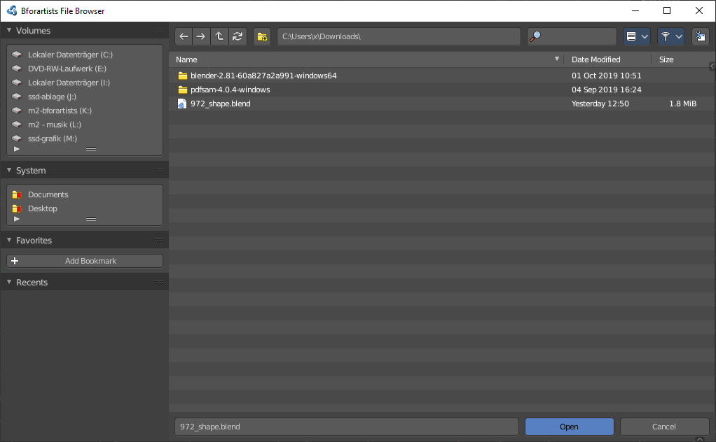
The file browser is an explorer dialog that allows you to browse for locations and files, and allows you to load and save them.
The file browser has multiple uses. While its often used for save/load, it can be kept open for other uses too.
In the file browser you can:
- Opening and Saving Blend files.
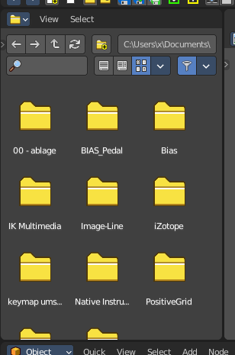
- Import/Export other file formats.
- Picking new locations for existing file-paths (images, video’s, fonts... etc).
- Browsing inside other .blend files, when using Append and Link.
You can also keep the file selector open, as with any other window type. In this case the buttons to load files is removed. This is for example done in the Shader editor workspace. This allows you to drag files directly into the editor where you need it.

File Browser Header

There are several tools in the header to find. The range goes from navigation elements across filters up to display options.

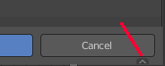
There are two header areas. The header area that contains the navigation and filter elements. And the editor header like in a traditional editor. This header is hidden when you use the file browser as a file selector. But it is still available. It resides at the bottom, and can be revealed by clicking at the small triangle button down right.
For this content see Footer Header chapter below.

Navigation
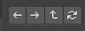
Navigate in the folder hierarchy.

Previous Folder
Navigate to the previous folder.

Next Folder
Navigate to the next folder.

Parent File
Go upwards in the hierarchy.

Refresh
Refresh the file list.


New Folder
Creates a new folder.

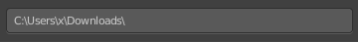
File path
The current directory.

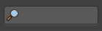
Search
Name Filter. Allows you to search for specific files and folders.

Display As

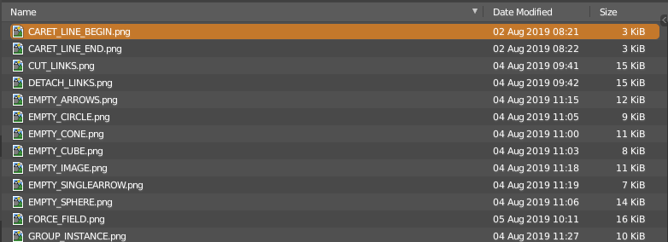
Vertical List
Displays the content of the file browser as a vertical list.

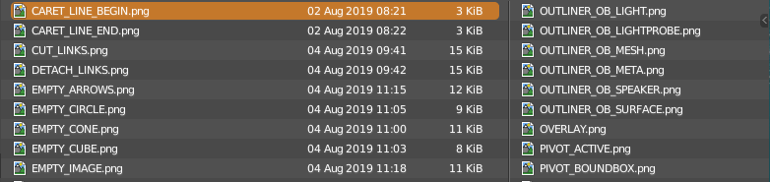
Horizontal List
Displays the content of the file browser as a horizontal list.

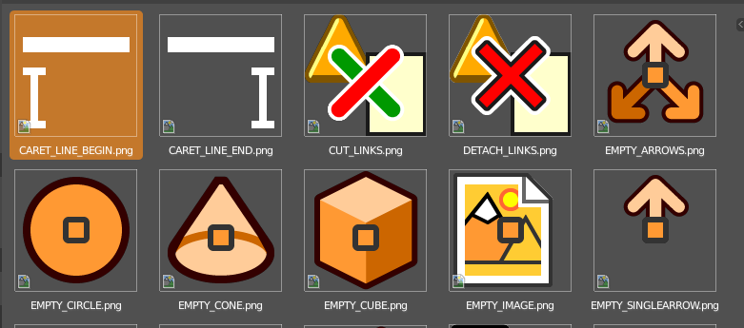
Thumbnails
Displays the content of the file browser as thumbnails. This is especially of use for images or blend files with thumbnail preview.

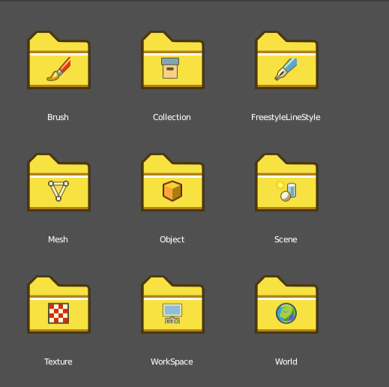
When you link or append from a blend file then the thumbnails also shows folders with icons for the different content of the library blend file.

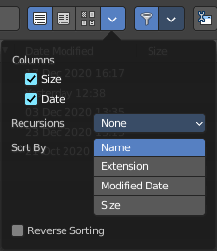
Display Options

Columns
When in columns view ...

Size
Display the size of the files.

Date
Display the creation date of the files.

Recursion
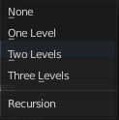
Adjust how deep the explorer should dig. Normally it just lists the content of the currently selected directory. But it is also possible to list the content of the folders three levels lower.
The recursion direction is always downwards. Default is None.

Sort by
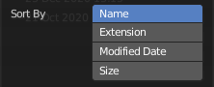
Sort the files by chosen method. The methods are self explaining.

Reverse Sorting
Reverts the sorting direction.

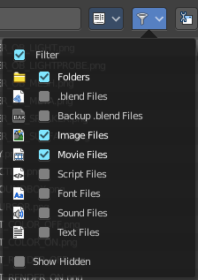
Filter

Filter
Enable the filtering.

Folders, etc.
The different file types that should be filtered. What is ticked here and what file types shows depends of what file browser you call. If you want to load a blend file. Or a FBX file from the File menu in the header. Or an image in the UV Editor for example.

Show Hidden
Shows hidden Dot files.
This is a Unix feature. Unix systems like Linux or Mac hides files from file browsers and explorers by having a dot before the file. A good example is the .htaccess file at servers. Show hidden Dot Files makes such files visible to the file browser.

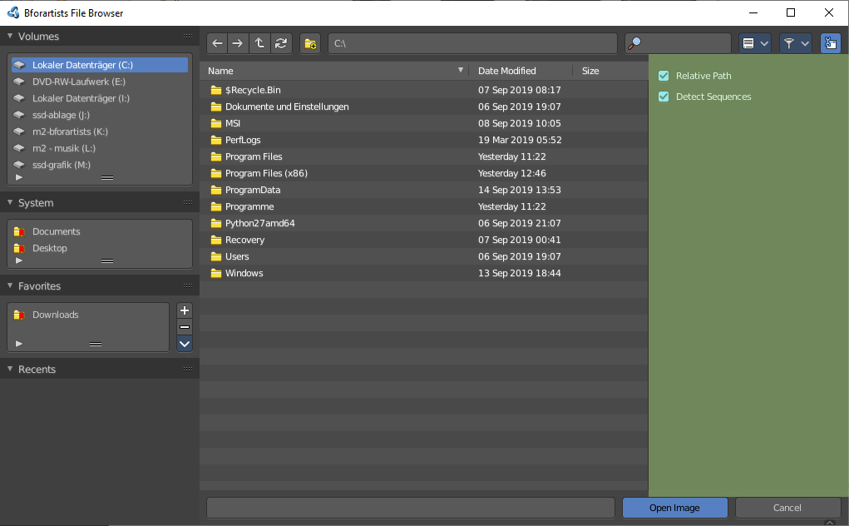
Toggle Region
Toggles the sidebar at the right. The sidebar contains various im- and export settings for the single file types.

Tool Shelf

The Tool Shelf at the left provides you with some panels for quick access to files and bookmarks.

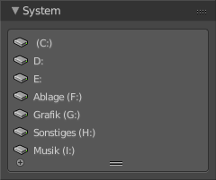
System Panel
Lists your drives.

System Bookmarks
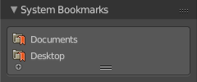
Lists some system libraries.

Favorites
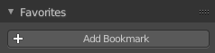
Add your own bookmarks. A direct bookmark towards the Downloads folder for example.
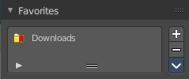

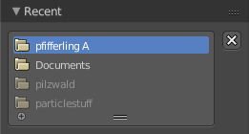
Recent
A list of the recent accessed folders.
Greyed out folders are not longer existing directories. There is unfortunately no way to remove them from within Bforartists. You would need to do this manually in the History text files in the settings folder.
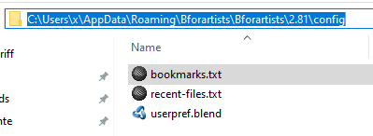
Under Windows this is the bookmarks.txt file in the Appdata folder.

Sidebar
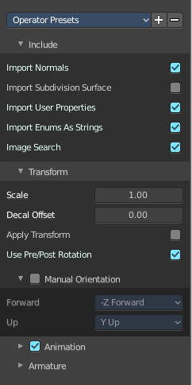
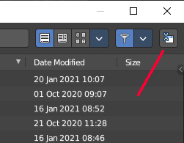
The sidebar is usually closed in most cases. Sometimes you need to open it. This can be done with a click at the Toggle Region button up right.

In the sidebar you will for example find the special Import or Export settings for the current file format. And here you will also find further settings. loading a Blend file you will just see two entries. When you append from a file then it's a bit more settings. And for file formats like FBX you will find all the settings for the current file format.
At the right you see the import dialog for FBX.

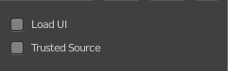
As an example, and to explain the two settings for loading a blend file:

Load UI
Bforartists comes with the feature *Load UI* unticked. This means the Bforartists UI will not change when you load a scene. Here you can temporary enable to load the scene with the layout and UI arrangement in which the scene was saved.

Trusted Source
With Load UI you can also load script files, which can execute. This is a potential security risk when the file comes from an unknown source.

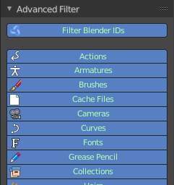
Advanced panel
When you append from a blend file, then you will find an Advanced panel with further filter settings in the sidebar. This filter allows you to filter the content for exact object types.

File dialog

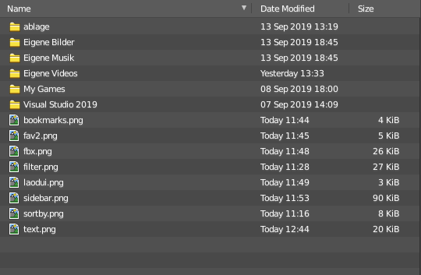
The file dialog is the actual place where your files and directories gets listed.

Click navigation.
Double clicking at a folder enters the folder. To go upwards in the hierarchy see Parent File button in the header.

Double Click to load
Double clicking at a file loads the chosen file when you are in a load dialog. The file dialog will then close.

Double click to save
Double clicking at a file overwrites the chosen file when you are in a save dialog.
The file dialog will then close.

Select and load more than one file
Holding down shift allows you to select and to load more than one file.

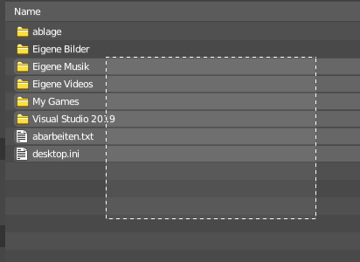
Box select
You can drag a box around the files by simply left clicking and moving the mouse.

Renaming
You can rename files and folders from within this list. Holding down ctrl and clicking at a file enters the edit file name mode.

File Name
The file that you want to load or to save.

Open / Save
Open or save the current file(s).

Cancel
Cancel the loading or save process and close the file browser.

Footer / Header

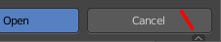
The footer is hidden by default when you call the file browser to load and save scenes and files. But contains some more functionality. And when you integrate the file browser into a workspace then the header shows at the top. In the Shading workspace for example.
You can reveal the footer by clicking at the triangle button at the right.
And then you will see the footer bar. Which will reveal two menus. View and Select.

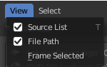
View Menu

Source List
Shows or hides the tool shelf at the left side.

File Path
Shows the header region with the file path and the navigation and filter elements.

Frame selected
Centers the selected elements.

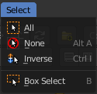
Select menu

Box Select
Allows you to box select files. Note that this is an old obsolete operator. You don't need to press the hotkey anymore for box select.

Inverse
Inverts the selection.

None
Select none.

All
Select all.

Files context menu

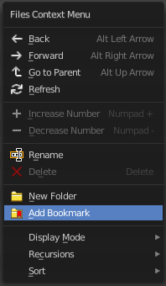
When you right click into the view then a files context menu opens. This menu comes from the File browser, and contains a few menu items that are not vaild for the asset browser. Like create a folder.

Back
Go to previous folder.

Forward
Go to next folder.

Go to Parent
Go upwards the hierarchy by one.

Refresh
Refresh the file list.

Increase Number
Increases the number at the selected data file in the file name edit box.

Decrease Number
Decreases the number at the selected data file in the file name edit box.

Rename
Rename the selected item.

Delete
Delete the selected item.

New Folder
Add a new folder.

Add Bookmark
Adds a bookmark in the file browser tool shelf in the Favourites panel.

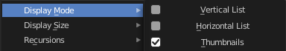
Display Mode
Display the content as a list or as icons.

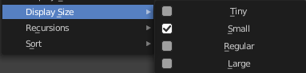
Display Size
Set the display size of the file browser to four predefined sizes.

Recursion
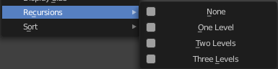
Recursion is a menu where you can adjust how deep the explorer should dig. Normally it just lists the content of the currently selected directory. But it is also possible to list the content of the folders three levels lower.
The recursion direction is always downwards. Default is None.

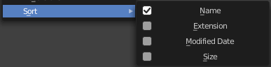
Sort
Sort the content by the chosen method.

